Blue Team Shooting Sports A.S.S.S. February 28th, 2026
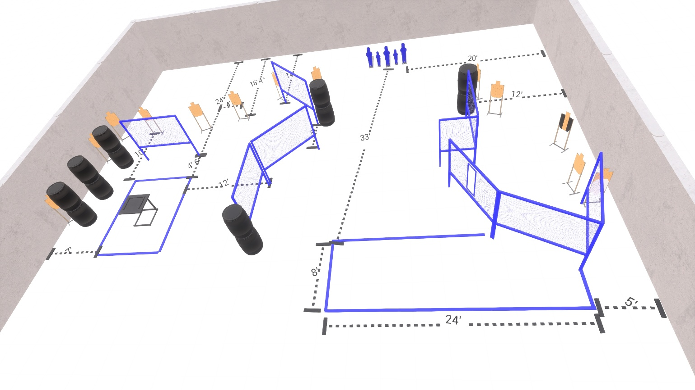

Written Stage Briefings:

Stage 3 - I'll be back, Bennett!
20 rounds, 100 points, Comstock.
10 Paper, best 2 hits score.
Start position Behind table, palms flat on table.
Gun: Unloaded, un-propped on table. First magazine / reloading device on table.

Stage 4 – I let him go.
15 rounds, 75 points, Comstock.
10 Paper, 5 Steel, best 2 hits score.
Start position Anywhere
Handgun: Loaded and holstered, wrists below belt
PCC: Loaded, stock touching belt

Stage 6 - Just Bodies.
31 rounds, 150 points, Comstock.
16 Paper, 5 Steel, best 2 hits score.
Start position Anywhere
Handgun: Loaded and holstered, wrists below belt
PCC: Loaded, stock touching belt

